1.4 For sinusoidal wing motion the low-pass sinusoidal transfer function is



For 5% error the magnitude must not drop below 0.95 K or



Solve for  with  = 2f = 2(100)





Phase angle  = tan–1 (–) at 50 z



at 100 Hz



1.8 For a first order instrument











2.4 From (2.21)

E = 38.7T + (0.082/2)T2 = 38.7T + 0.041T2

|  |  |  |  |
| --- | --- | --- | --- |
| T  °C | 38.7T  µV | 0.41T2  µV | E  µV |
|  |  |  |  |
| 0 | 0 | 0 | 0 |
| 10 | 387 | 4 | 391 |
| 20 | 774 | 16 | 790 |
| 30 | 1161 | 37 | 1196 |
| 40 | 1548 | 66 | 1614 |
| 50 | 1935 | 102 | 2037 |

The second term is small. The curve is almost linear but slightly concave upward.

2.7 There is always a voltage induced in each secondary, because it acts as the secondary of an air-core transformer. This voltage increases when the core is inside it.

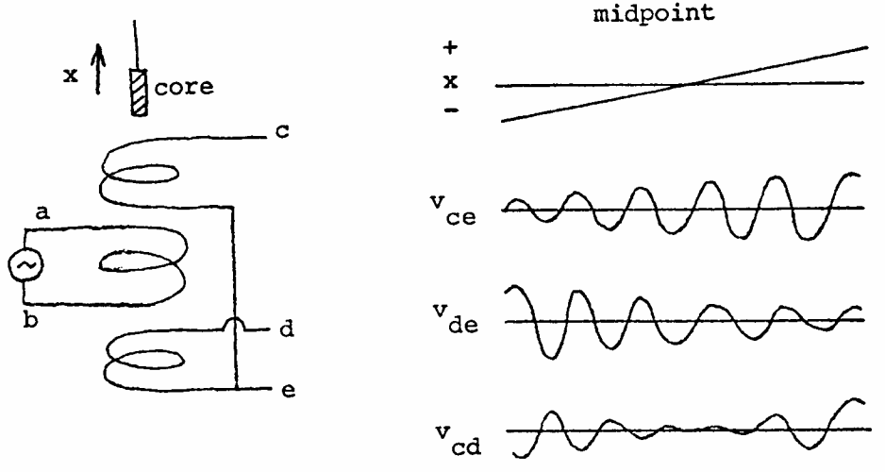

2.8 In Example 2.3 C = 500 pF for the piezoelectric transducer. The amplifier input impedance = 5 MΩ.

F = 0.05 Hz =

Thus Cequivalent = 0.637 × 10–6 = Cpiezoelectric + Cshunt

Cshunt = 0.636 µF = 636 nF

Q = CV, where charge Q is fixed, capacitance C increases by 636 nF/0.5 nF = 1272 times. Voltage V (sensitivity) decreases by 1/1272.

The sensitivity will be decreased by a factor of 1272 due to increase in the equivalent capacitance.